Administration for the Prevention of Money Laundering
2024 Annual Report

Belgrade, March 2025
Administration for the Prevention of Money Laundering
24 Resavska, 11000 Belgrade

Contents:
NATIONAL COORDINATION, RISK ASSESSMENT, AML/CFT STRATEGY 3
LEGAL AFFAIRS AND HARMONISATION OF LEGISLATION WITH INTERNATIONAL STANDARDS 3
Law on the Prevention of Money Laundering and Terrorism Financing (AML/CFT Law) 3
Law on the Freezing of Assets with the Aim of Preventing Terrorism and Proliferation of Weapons of Mass Destruction (LAF) 4
APML opinions concerning the implementation of the AML/CFT Law 4
Professional licensing examination for compliance officers 5
INTERNATIONAL COOPERATION 5
Participation in MONEYVAL activities 5
Cooperation with the Council of Europe 5
Interaction with FATF 6
Egmont Group related activities 6
Cooperation with the Eurasian Group (EAG) 7
Other international cooperation 7
Cooperation with the US Embassy in Belgrade, OPDAT, EXBS 7
Cooperation with the UK Embassy in Belgrade 7
Cooperation with the Italian Embassy in Belgrade 7
Interaction with GIZ 8
APML role in the EU - Serbia negotiation process 8
Interaction with OSCE 8
Cooperation with foreign FIUs 8
FINANCIAL INTELLIGENCE 8
SECTOR FOR ANALYSIS AND COUNTER-TERRORIST FINANCING 8
PREANALYSIS TEAM AND STR ANALYSIS SECTION 9
SECTION FOR INTERAGENCY COOPERATION 9
Prosecutors’ offices 9
Ministry of the Interior 10
Security Information Agency 10
Tax Administration 10
Agency for the Prevention of Corruption 10
National Bank of Serbia 10
Customs Administration 11
Cooperation with foreign counterparts 11
COUNTERING THE FINANCING OF TERRORISM (CFT) TEAM 11
Other forms of interagency cooperation and SAR analysis 12
International cooperation 12
MONEY LAUNDERING TYPOLOGIES 12
Trade in used cars 12
SUPERVISION OF ACCOUNTANTS AND FACTORING FIRMS FOR COMPLIANCE WITH THE AML/CFT 16
Preventive activity - dissemination of guidance papers 17
Court decisions 17
IT SUPPORT FOR APML CORE FUNCTIONS 18
INTERNAL ORGANISATION AND HUMAN RESOURCES 18
APML FINANCIAL REPORT 19
FATCA IMPLEMENTATION TEAM 19
ANNEX 1 TRAINING EVENTS ATTENDED BY APML STAFF (AUDIENCE AND/OR PRESENTER(S).....................................................................................................................................................................25

NATIONAL COORDINATION, RISK ASSESSMENT, AML/CFT STRATEGY

Representativeas of the Administration for the Prevention of Money Laundering (APML) were active in the National Coordination Body for the Prevention of Money Laundering and the Financing of Terrorism (AML/CFT Coordination Body) as experts and technical support staff.
The AML/CFT Coordination Body was focused on implementing all major strategic activities:
- National Risk Assessment update. 2024 saw the beginning and completion of the ML/TF/PF NRA documents, adopted by Government at its session of 5 December 2024
- 6th Round Mutual Evaluation of the Republic of Serbia by MONEYVAL. This process started in July by country training by Moneyval Secretariat staff, and will last until December 2025, i.e. until the Moneyval Plenary considers and adopts the Mutual Evaluation Report for Serbia.
- Monitoring and reporting on the implementation of the Action Plan accompanying the Strategy against Money Laundering and the Financing of Terrorism (2022-2024) (AML/CFT Strategy)

AML/CFT Coordination Body expert teams (11 of them) actively worked and completed their tasks as planned. Development of a risk assessment for the real estate sector was amongst the most important activities. An initiative was made based on which the NBS amended its decision on payment codes (new payment codes were introduced for digital assets and real estate trade), new ML typologies and TF modalities and trends were published, etc.
Given that the validity of the AML/CFT Strategy and the AP 2022-2024 was to expire at the end of 2024, the APML requested in December 2024 the competent authorities to nominate members/deputy members of the working group tasked with the development of the new AML/CFT Strategy (i.e. Strategic-Operational Plan) for 2025 - 2029.
The First Deputy Prime Minister and Minister of Finance established the working group to develop the document, to be adopted in the first quarter of 2025. The new national strategy will be based on the outcomes of the analysis of the implementation report for the previous strategy and AP, as well as the findings of the most recent NRA.

LEGAL AFFAIRS AND HARMONISATION OF LEGISLATION WITH INTERNATIONAL STANDARDS

Law on the Prevention of Money Laundering and Terrorism Financing (AML/CFT Law)

The current Law on the Prevention of Money Laundering and Terrorism Financing (AML/CFT Law) was adopted on 14 December 2017 with the aim of harmonizing the national AML/CFT legislation with international standards (FATF recommendations, Fourth European Union AML Directive), as well as the MONEYVAL 2016 Mutual Evaluation Report (MER) recommendations.
In addition to the amendments in 2019 and 2020, this Law was amended in 2024 too with the aim of extending the requirement to develop an NRA also for the area of proliferation financing, and so that the obliged entities apply adequate measures to prevent and detect not only ML and TF but PF as well. Some amendments were also motivated by Moneyval recommendations, i.e. the need to achieve technical compliance with the FATF recommendations.
In addition, risk considerations too were a motivating factor, especially when it comes to the real estate sector, which has been found to be a high risk for money laundering.
One of the recommendations of the AML/CFT Coordination Body expert team, which was tasked with developing the real estate ML risk assessment, involves the restriction on transactions related to purchase and payments by natural persons in cash in the real estate sector, which resulted in the appropriate amendments to the AML/CFT Law.
Responding to the ML risks and vulnerabilities found, the government also intervened to prevent integration of dirty money generated through the commission of the criminal offense of usury. This was the reason for the amendments introducing restrictions with respect to the receipt of cash by a natural person in the amount of the RSD equivalent of EUR 10,000 or more also under a loan contract. Such loan amounts now must be paid to the bank account.
The AML/CFT Law is further specified in two by-laws: Rulebook on the Methodology for Complying with the AML/CFT Law and Rulebook on the professional licensing examination for compliance officers.

Law on the Freezing of Assets with the Aim of Preventing Terrorism and Proliferation of Weapons of Mass Destruction (LAF)

LAF was first passed on 20 March 2015. The main objective of this law was to improve the fight against terrorism by establishing a system of preventive and repressive measures against terrorist financing as the prior necessary step in the commission of terrorist acts. By passing this legislation, Serbia complied with the provisions of Chapter VII of the United Nations (UN) Charter, which requires that the UN member states take measures to implement resolutions adopted by the UN Security Council (UNSC) within its powers.
In 2024, LAF was amended to specify its provisions on supervision, so that it is now clear that compliance with this law by financial institutions and DNFBPs is supervised by the same supervisors as those supervising compliance with the AML/CFT Law.
For instance, the NBS will supervise LAF compliance by banks, insurance companies, currency exchange operators, etc. Securities Commission will supervise broker-dealer companies, investment fund management companies, etc., Chamber of Notaries Public supervises notaries, etc.
LAF is further specified in the Rulebook on the manner of notifying natural and legal persons about modifications to the lists of designated persons and on the manner of filing reports, information and data concerning a designated person and their assets.

APML opinions concerning the implementation of the AML/CFT Law

The Team for legal affairs and harmonization of legislation with international standards has the responsibility of drafting opinions concerning the application of the AML/CFT Law, and by-legislation passed based on this law.
The opinions are posted on the APML website, section ‘Strucna misljenja’:
http://www.apml.gov.rs/pretraga-strucnih-misljenja

Professional licensing examination for compliance officers

In 2024, APML completed 4 licensing examinations, each comprising a written test and oral examination.
Pursuant to Article 18 of the Rulebook on the Professional Licensing of Compliance Officers, APML issued 104 compliance officer licenses.

INTERNATIONAL COOPERATION

Participation in MONEYVAL activities

Two MONEYVAL plenary meetings were held in Strasbourg in 2024: 67th on 21-24. 5.2024 and 68th from 2-6.12.2024. The meetings were attended by a Serbian delegation consisting of the APML Acting Director, representatives of the Ministry of Internal Affairs, Ministry of Justice and the National Bank of Serbia (NBS).
Also, on February 5, 2024, a virtual meeting was held regarding the draft Effectiveness Questionnaire as part of the 6th round of evaluations, and on July 2, 2024, a second thematic intersessional meeting was held on the necessary additional resources for the 6th round of evaluation.
An online meeting of the Heads of Delegations was also held on 12.9.2024 regarding the need for additional funding for the Moneyval Committee.
The APML Acting Director was a member of the Moneyval assessment team under the 5th round of the evaluation of Bosnia and Herzegovina, as a LEA assessor. The onsite assessment, lasting almost three working weeks, took place in February 2024, and the evaluation report for BiH was adopted at the December session.
At the request of Moneyval, the APML reported on the scope and quality of Serbia’s international cooperation with the competent authorities of Belgium, Latvia, Austria and Italy in the context of their mutual assessment processes.
In the context of preparations for the 6th round of evaluation, two representatives of the Moneyval Secretariat held the country training for Serbian stakeholders on 3-4 July 2024 on NBS premises.
As of September 2024, the staff of the APML and other competent authorities started filling out the Technical Compliance Questionnaire, which was forwarded to Moneyval on October 28, 2024, together with the Materiality Questionnaire. The APML and authorities were also actively engaged on preparing the information for the Effectiveness Questionnaire. The APML played a leading role in this process as the coordinator and organizer of a number of meetings.

Cooperation with the Council of Europe

The APML has nominated its representative for the Cyber SEE project, which is a continuation of the i-Proceeds project dealing with confiscation of proceeds from cybercrime. An APML representative attended the opening of this project in Strasbourg on 17 June 2024.
As part of the Project Preventing Money Laundering and Financing of Terrorism in Serbia, funded by the Swedish International Development Agency and implemented by the Council of Europe, a Workshop on the FIU Prioritization Plan was held in Belgrade on 24-25.6.2024, facilitated by two Council of Europe experts.
As part of the joint EU/CoE project Regional Action against Economic Crime in the Western Balkans, the APML was visited by a CoE expert in charge of monitoring the achieved results (Result oriented monitoring - ROM) at the end of October 2024.

Interaction with FATF

FATF (Financial Action Task Force) is an international body that sets global standards for combating money laundering and terrorist financing, and whose compliance in individual countries is subject to assessment (evaluation) by regional bodies that function according to the FATF model (FATF-style regional bodies, FSRBs ), which in the case of the Republic of Serbia is the Moneyval Committee.
An APML representative attended the FATF online course on beneficial ownership in relation to Recommendations 24 and 25, as well as Immediate Outcome 5.
The APML facilitated the participation of prosecutors and representatives of the Ministry of Internal Affairs in two closed webinars on parallel financial investigations and evidentiary standards and best practices in prosecuting ML.
According to established practice, the APML shares with the FATF on a quarterly basis any updates on ISIL and Al-Qaeda links, as well as any action taken in terms of informing obliged entities about high-risk countries against which the FATF requires certain measures to be taken.
In October 2024, the APML submitted its contribution for updating the comprehensive report on terrorist financing risks, prepared by the FATF Working Group on Risks, Trends and Methodology.
The APML also worked jointly with the NBS to prepare an input for the updated FATF report on the implementation of Recommendation 15. The APML also invited the NBS and the Securities Commission to appoint a representative to the FATF Contact Group (VACG).

Egmont Group related activities

Egmont Group is a global association of financial intelligence units which promotes cooperation, financial intelligence exchange using the Egmont Group secure website.
Members of the Egmont Group must meet certain standards and criteria contained in the Egmont Group Charter and Principles for Information Exchange.
As of March 2025, Egmont Group has 177 member FIUs.
Egmont Group meets once a year in a plenary session, and once more at the level of its working groups.
Two important meetings were held in 2024.
1) Annual Egmont Group Working Group and Regional Group meetings from 29/1 to 2/2/2023 in Malta. APML was represented at the meeting by Head of Team for international cooperation, training and projects.
2) 30th Egmont Group plenary and working group meetings were held on 2 - 6 June 2024 in Paris. The meeting saw the signing of an MoU between the APML and FIU Japan, as the relevant regulations of Japan require an MoU for exchanging information with foreign FIUs.
The year of 2024 also saw a new round of EG Biennial Census, i.e. the FIUs completed a detailed questionnaire on the organization and functioning of their FIUs which serves as a tool helping FIU cooperate better.

Cooperation with the Eurasian Group (EAG)

The EAG is a FATF-style regional body gathering together the Russian Federation, Belarus, the former Soviet Union Asian countries, India and China.
The APML has an observer status in the EAG since 2010.
In 2024, two EAG plenaries were held, along with working group meetings (so called plenary week). The first plenary week was held on 27-31.5.2024 in Bishkek, Kyrgyz Republic, and the APML was represented at the meeting by Head of Team for international cooperation, training and projects.
APML was not represented at the second plenary event, which was held on 25-29.11.2025 in Indore, India.
In March 2024, EAG Secretariat requested the APML to assist in preparing training material for Kazakhstan police officers on predicate crime investigations. In cooperation with Public Prosecutor’s Office for Organized Crime, the APML was able to share several relevant case studies for the purpose.
In September 2024, APML Director, a. i. contributed a paper on the current state of affairs in the Serbian AML/CFT system, for the EAG’s Financial Security magazine.
APML staff member attended a Joint Assessors’ Training organized by EAG and FATF on 4-8.11.2024 in Almaty, Kazakhstan.

Other international cooperation

Cooperation with the US Embassy in Belgrade, OPDAT, EXBS

Successful cooperation with the US Embassy in Belgrade continued on the training for law enforcement on ML and VAT fraud where APML staff are also engaged as trainers. The training events were held on 7-9.2.2024, 20-22.3.2024 (VAT Fraud), and 29-31.5.2024 (money laundering).
Cooperation was also continued with the US Government Export Control and Related Border Security Assistance - EXBS program whose experts held on 16.1.2024 and online meeting with APML and other authorities on the development of PF risk management action plan. A WMDPF and sanction evasion workshop was held in Belgrade on 15-17.4.2025 which was attended also by APML staff.

Cooperation with the UK Embassy in Belgrade

An assistant APML director took part in a study visit, organized by the UK Embassy in Belgrade, to the UK HMRC authority in London, on 13-16.5.2024.

Cooperation with the Italian Embassy in Belgrade

In December 2024, the new attaché of Guardia di Finanza made his introductory visit, on which occasion both parties expressed their willingness to continue their successful cooperation.

Interaction with GIZ

The APML cooperates with the German GIZ under the Global Program Combating Illicit Financial Flows. From 24-25.9.2024 in Skopje, a conference on the achievements so far and future plans in the area of financial investigations, asset recovery, socially responsible management of recovered assets, from the perspectives of FIU, prosecutor’s office and police. Two APML staff attended the conference.

APML role in the EU - Serbia negotiation process

APML contributes to the EU accession negotiation process by following EU AML/FT standards and timely planning of harmonization of Serbian legislation with these standards.
In particular, APML mainly takes part in the in the negotiations for chapters 4 (free movement of capital), 24 (justice, freedom and security), 31 (common foreign and security policy).
APML staff member took part at the meeting of the Subcommittee on Justice, Liberty and Security, 12-13.3.2024.
APML prepared its input for the revision of the Joint AP in preparation for a TAIEX expert mission in the area of preventing/suppressing terrorism, 10-12.4.2024.
At mid-2024 APML was involved in the preparation of Serbia’s application to join the EU Single Euro Payments Area – SEPA.

Interaction with OSCE

APML contributed to the drafting of the report concerning the Code of Conduct in Politico-Military Aspects of Security.

Cooperation with foreign FIUs

The APML hosted on 04-05.9.2025 colleagues from FIU Montenegro (General Police Directorate, Financial Intelligence Sector).
The meetings mainly involved the topics of prioritization of cases and activities related to the 6th round Moneyval evaluations.

FINANCIAL INTELLIGENCE

SECTOR FOR ANALYSIS AND COUNTER-TERRORIST FINANCING

Sector for analysis and prevention of the financing of terrorism comprises a Section for analysis of suspicious transactions, Section for interagency cooperation, Team for pre-analysis and Team for prevention of terrorism financing (CFT Team).
In 2024, the Sector for analysis and counter-terrorist financing opened 1.239 new cases. In addition to working on newly opened cases, APML analysts acted upon a large number of cases which were opened in previous years.

PREANALYSIS TEAM AND STR ANALYSIS SECTION

In the reporting year, obliged entities filed 2,014 suspicious activity reports. The total value of SARs filed amounts to RSD 311,003,921,880.46 (EUR 2,655,584,824.99). An overview of the SARs by obliged entities is shown in the table below:

Obliged entities | Number of SARs
Banks | 1.161
Entrepreneurs and legal persons providing accounting services | 12
Auditing companies and independent auditors | 6
Insurance companies | 12
Factoring firms | 0
Broker-dealer companies | 2
Postal operators | 15
Real estate trade and lease agents | 8
Lawyers | 0
Notaries public | 189
Payment institutions | 145
Authorized currency exchange offices | 275
Organisers of special games of chance in casinos | 5
Games of chance providers using electronic communications | 85
Financial leasing providers | 9
E-money institutions | 66
VASPs | 18
Voluntary pension fund management companies | 0
Investment fund management companies | 3
Central Securities Depository and Clearing House (CSD) | 3

Of the total number of SARs, 851 were related to the cases carried forward, i.e. cases opened in previous years, while new pre-analytical cases were opened in relation to 1.163 SARs.
The number of SARs filed shows an increase compared to the previous year. The increase in SARs coming from banks is notable. In addition to quantity, the quality of bank SARs also improved. One of the reasons for this is attributed to purchases of new software and improvement of the analysis systems and processes at banks which improved their effectiveness in identifying potential suspicious activities performed through their banks, which may indicate suspicion on ML or TF.
Also, the APML in 2024 sent a total of 8,137 requests to obliged entities with the aim of obtaining additional information required for analysis.

SECTION FOR INTERAGENCY COOPERATION

Prosecutors’ offices

Competent public prosecutor offices filed a total of 80 requests to the APML.

Prosecutor’s office | Number of requests
Public Prosecutor’s Office for Organised Crime | 16
Higher prosecutor’s offices | 61
Basic public prosecutor’s offices | 3

The APML made a total of 97 disseminations to relevant prosecutors’ offices.

Prosecutor’s office | Number of disseminated reports
Public Prosecutor’s Office for Organised Crime | 11
Prosecutor’s Office for Cybercrime | 6
Higher prosecutor’s offices | 80

Regional distribution of information disseminated to higher prosecutor’s offices is shown in the table below.

Higher Public Prosecutor’s Office | Number of disseminated reports
Belgrade | 41
Kraljevo | 7
Niš | 8
Novi Sad | 24

Ministry of the Interior

The Ministry of the Interior sent a total of 135 requests to the APML on suspicion of money laundering or terrorism financing.

Security Information Agency

The Security Information Agency sent 57 requests for information to the APML, requesting checks of APML databases including bank account turnovers and information on transactions carried out through payment institutions.
In addition, after analysing STRs, the APML made a total of 28 disseminations to the Security Information Agency for potential follow up.

Tax Administration

The Tax Administration sent 19 requests for information to the APML and the APML made 99 disseminations to the Tax Administration for further follow up.

Agency for the Prevention of Corruption

The APML received two letters from the Agency for the Prevention of Corruption indicating suspicion on ML. APML had no requests for information for this agency.

National Bank of Serbia

The National Bank of Serbia (NBS) sent to the APML 40 requests for information on STRs sent in by obliged entities (number and quality of STRs and CTRs) and for a check of information about persons acquiring bank shares, as well as about persons intending to provide intermediary services in insurance business.
The APML sent the NBS 2 letters indicating ML suspicion.

Customs Administration

The Customs Administration made a total of 13 disseminations to the APML, due to suspicion of money laundering. In the same period APML sent 20 requests for information to a relevant authority, which were based on information received from Customs Administration.

Cooperation with foreign counterparts

The APML responded to 121 requests of foreign counterparts, and as part of its work on its own cases, the APML sent 113 requests for information to foreign FIUs.
An overview of FIUs with which the APML exchanged most of the information is shown in the table below:

 | Requests by foreign FIUs | APML’s requests
North Macedonia | 3 | 5
Bosnia and Herzegovina | 12 | 6
Germany | 2 | 7
Italy | 5 | 3
Malta | 6 | 0
Montenegro | 35 | 9
Slovenia | 5 | 4
United States of America | 4 | 7
Croatia | 3 | 4
Cyprus | 1 | 5
Czech Republic | 4 | 1
Hungary | 1 | 4
Slovakia | 1 | 6
United Arab Emirates | 2 | 10
United Kingdom | 6 | 2

COUNTERING THE FINANCING OF TERRORISM (CFT) TEAM

In addition to daily activities required by the Action Plan in terms of cooperation with other authorities, foreign counterparts and relevant international entities, the AP activities which are ongoing in nature or those with a forthcoming deadline were started, such as organization of training on alternative asset transfer methods and misuse of modern technologies for TF, participation in compliance officer licensing process, or participation in the NPO Supervision WG.

Other forms of interagency cooperation and SAR analysis

Team for TF Prevention has intensive cooperation with the PPOC, BIA and MoI Service against Terrorism on collecting and analyzing financial information related to persons suspected to be involved in terrorist activities.
The Team checked all the suspicious entities referred to in the requests of other authorities, foreign counterparts and SARs, thereby succeeding in meeting the target set under Measure 4.1 of the AML/CFT Action Plan.

International cooperation

Team for TF Prevention continues to support preparation of regular FATF reports on TF trends and techniques to prevent TF.

MONEY LAUNDERING TYPOLOGIES

Trade in used cars

ML through used car trade continues to figure as one of the typologies. Money of unknown origin is paid as daily receipts in favor of a legal entity that deals with the sale of cars. The legal entity further transfers the money on the basis of fictitious invoices in favor of another domestic legal entity from whose accounts payments are made to legal entities abroad for the purpose of purchasing a car.
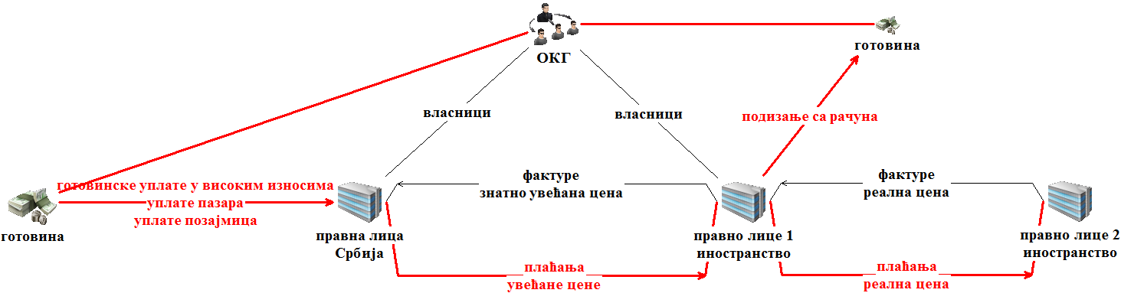

- Misuse of payment institutions for concealing the origin of funds

A phenomenon has been observed of individuals frequently using payment institution services in transactions related to payment operations. More specifically, instead of going to a commercial bank, such individuals are using a payment institution’s services to deposit their cash to certain bank accounts at such banks. The deposits are mainly payment of founder’s liquidity loans and daily receipts deposits. There are examples of individuals depositing cash to their personal accounts in commercial banks through payment institutions.

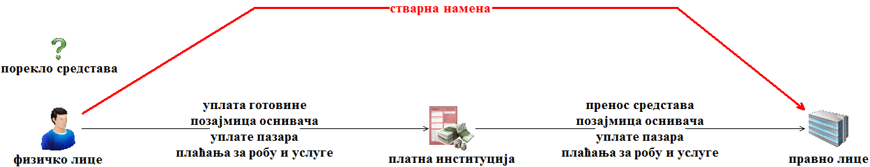

- Transit transactions

Transactions i.e. transfers of large amounts of funds in international payment operations where the legitimate economic purpose of such transactions is not obvious are frequent. These are mainly so called ‘transit transactions’ originated by legal entities located abroad which funnel funds to Serbian legal entities, which may be owned by both resident or non-resident individuals, usually based on invoices for services, and such funds are then on the same day further transferred also based on invoices for services to bank accounts of other legal entities located in numerous foreign countries, often including in offshore areas. In such cases it is difficult to identify the actual purpose or economic rationale for the executed transfers, and are thus believed to be carried out with the aim of concealing and disguising dirty money.

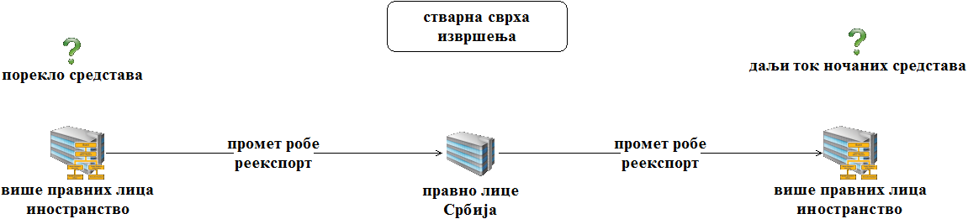

- Fraud/trade in digital assets

In the recent years, we noticed frequent cases of fraud related to provision of VA-related services. More specifically, individuals are transferring funds in favor of another individual’s bank account (who pretends to be a broker) for the purpose of an alleged purchase of digital assets (VA). The individuals who made the transfers to buy VA never received their VA, so the money or VA itself was appropriated by the individuals who received the transfers.
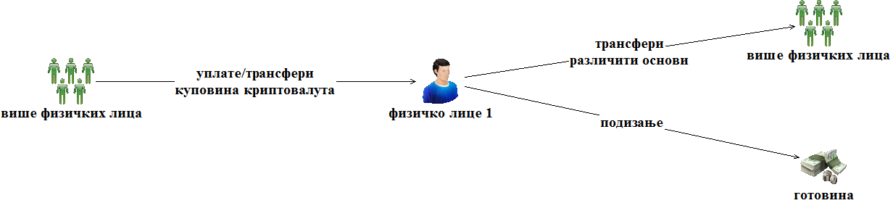
- Misuse of personal bank accounts for business purposes

Personal accounts have been found to be used for transferring funds from and to personal and legal entity bank accounts based on turnover of goods and services. The funds thus accumulated are then further transferred to the benefit of other persons also based on the turnover of goods and services or are withdrawn from the bank account. Such activities indicate that the specific person is engaging in an unregistered business activity and that in this way, using personal accounts, they conceal the income generated.
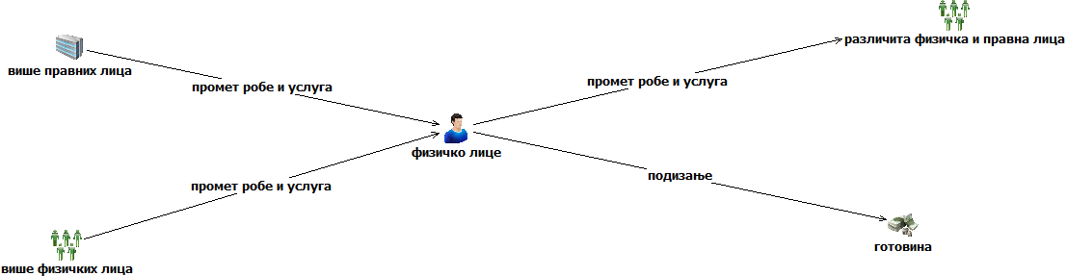

- Opening of bank accounts by non-resident natural persons in commercial banks operating in the Republic of Serbia for the purpose of concealing income

Non-resident natural persons, in order to conceal their income generated abroad, open accounts in commercial banks operating in Serbia, mainly in border areas. The bank accounts opened in this way are credited from abroad based on fees, most often for IT services. The goal of these transactions, i.e. the aim of opening of accounts in Serbia, is to conceal the income generated in the home country.
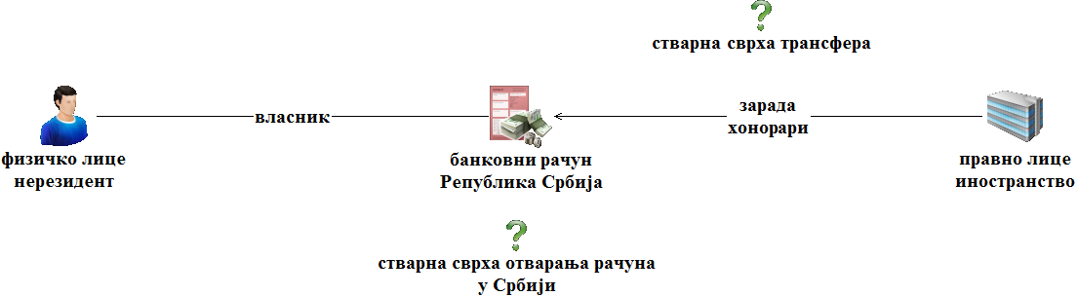

- Depletion of legal entity bank accounts

In order to drain funds from the accounts of legal entities, transfers are often made to the accounts of several entrepreneurs for alleged sale of goods and services, using forged invoices. The funds are then immediately transferred from entrepreneur's account to the accounts of individuals or withdrawn from the account. For the purpose of depleting the accounts, purchase orders relating to the purchase of agricultural products or secondary raw materials are often used.
In the second half of 2024, a modality of legal entity account depletion based on the alleged lease of machines was observed. More specifically, funds are transferred from the legal entity’s account on these grounds to the bank accounts of natural persons who immediately withdraw the funds from the account.
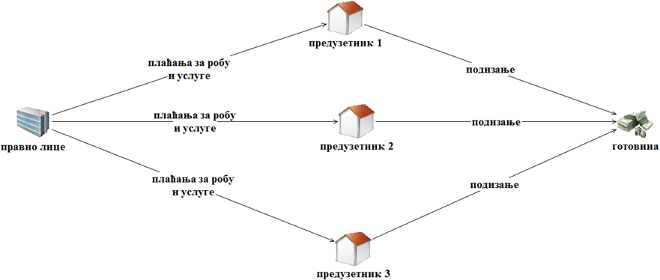

- Simulated transactions and placement of proceeds in digital assets

It has also become common for transactions between legal entities to be carried out on the basis of documentation that is suspected of being misstated, i.e. the true purpose of the transactions is dubious. The money acquired in this way is then invested in the purchase of digital assets.

- Unjustified salary and bonus payments

In order to use a legal entity’s funds for personal purposes, the founders, i.e. the owners, pay themselves or specific employees’ salaries, i.e. non-taxable income or bonuses in very high amounts. A comparison of the earlier salaries of the same persons with the salaries and bonuses that the person now earned, showed they were not paid in realistic, but significantly increased amounts. The persons most often place the funds generated in this way in the purchase of movable or immovable property.

- Loans using illegal funds

Loans between natural persons are often used to conceal the illegal origin of funds and integrate it into legitimate economy. Specifically, a person who illegal money gives a loan to the borrower, and as a guarantee, the person invests the funds in real estate. Where the loan is not repaid in money, the real estate title passes on to the lender.

SUPERVISION OF ACCOUNTANTS AND FACTORING FIRMS FOR COMPLIANCE WITH THE AML/CFT

Under Articles 105-108 of the Law, the APML carries out offsite and onsite supervision of compliance with the Law and the LAF by the following obliged entities:

- entrepreneurs and legal entities engaged in the provision of accounting services and
- factoring companies (hereinafter: obliged entities).

In addition, the APML carried out an analysis of cross-border threats in obliged entities. More specifically, data was requested from obliged entities concerning the registered office of clients with which they were in a business relationship in 2023 (as on 31 December 2023), about the countries where their clients operated in the same period, information concerning the level risk they classified their clients as on 31 December 2023, based on Article 6 of the AML/CFT Law, information concerning their client’s organization form, and whether the client ownership structures included any trusts in the same period. Based on the collected information, an Analysis of Cross-Border Threats at these entities, as well as auditing companies which also offer accounting services was made.
Off-site inspection is conducted by sending out questionnaires on the compliance with AML/CFT requirements by the supervised entities, and questionnaire on compliance with the Law on Asset Freezing, by analyzing the responses and also by providing additional clarifications. In the case of entrepreneurs (sole traders) and legal persons engaging in accounting services, the criteria based on which the APML identifies the obliged entities to which it will send the AML/CFT Questionnaire include the number of employees, geographic prevalence, annual revenue and net profit of the company or entrepreneur. When it comes to factoring companies, the AML/CFT questionnaire was sent out to all registered factoring companies that have available the details referred to in the questionnaire.
The questions in the AML/CFT questionnaire are divided in seven sections: general information on the obliged entity, obliged entity activities, information about obliged entity’s clients, reporting to the APML, ML actions and measures taken, TF actions and measures taken, and other measures by the obliged entity. The questions in the LAF questionnaire are divided in two sections - general information about the obliged entity and the obliged entity activities.
The total number of entrepreneurs and legal entities engaged in the provision of accounting services in the Republic of Serbia in 2024, registered in the Register of Accounting Service Providers maintained by the SBRA, was over 5,500. 159 of them were covered by offsite supervision, including: 158 limited liability companies and 1 partnership, who were sent questionnaires about both laws which they had to return filled in 15 days.
The APML also sent the two offsite supervision questionnaires to 26 audit firms which also provide accounting services in addition to auditing, and this offsite supervision also covered their affiliated legal entities that provide accounting services.
There was a total of 21 factoring company in Serbia in 2024. All companies were covered by the APML’s offsite supervision, which means that they were provided with Questionnaires from the field of both laws and were given a period of 15 days to respond.
All of the offsite inspections above were completed in the year in the reporting year.

Preventive activity - dissemination of guidance papers

The APML has shared guidance papers to newly established factoring companies (3) to familiarize them with the obligations they have under both laws.
Onsite supervision is conducted by inspecting general and individual acts, records and documentation, as well as business books, extracts from accounts, correspondence and other documents on the supervised subject’s premises or those of the entity directly or indirectly related to the supervised subject, by taking statements from the responsible person or other supervised subject’s employees, as well as by requesting information from state authorities and holders of public authority and inspecting documentation.
Risk-based approach was applied in the development of the 2024 Onsite Inspection Plan; this approach means that the obliged entities that are assessed as having a higher ML/TF risk exposure in the performance of their registered business will be prioritized accordingly in the Onsite Inspection Plan timetable.
The following elements were used as criteria for assessing ML/TF risk exposure:

1. NRA findings. In terms of sectoral exposure to ML, the National ML/TF Risk Assessment, found accountants to be exposed to a medium to low ML threat, and factoring companies to a low ML threat. In terms of sectoral vulnerability, the accounting sector was classified as a medium vulnerability group (compared to other DNFBPs), whereas the factoring sector was classified as low vulnerability group (compared to other financial sectors);
2. Offsite inspection findings. In case that they reveal certain irregularities, the onsite inspection will be used to verify the factual situation;
3. Number of employees at the obliged entity;
4. Obliged entity’s annual revenue;
5. Information received by the APML from other state authorities and anonymous persons;
6. Information obtained from APML’s databases.

In conducting supervision of the compliance with the Law, inspectors look at what kind of AML/CFT actions and measures are undertaken by the obligors.

In the reporting year, the APML carried out onsite examination of 16 obliged entities (27 legal entities and 6 sole traders) providing accounting service, including through:
- 16 regular onsite inspections for compliance with the Law, with irregularities found in 15 of them (83 economic offenses and 40 misdemeanors found), which resulted in the filing of 10 economic offense reports and 5 requests to initiate misdemeanor proceedings;
- 10 extraordinary onsite inspections for compliance with the Law on Central Records of Beneficial Owners, in which no irregularities were found and
- 5 extraordinary onsite inspections of the implementation of LAF, all of which found irregularities which related to the failure of the supervised obliged entities (legal entities) to determine, when performing their work or activity, whether they had business or other similar relationships with a designated person.

Court decisions

The APML has received a feedback about 20 court decisions related to the proceedings initiated in the previous period, of which 8 court decisions involved legal entities and 12 entrepreneurs.
The total amount of fines imposed on the legal entities was RSD 1,330,000.00, while the responsible persons in the legal entities were fined a total of RSD 243,000.00.
The total fines imposed on the entrepreneurs was RSD 925,000.00. Two entrepreneurs were sanctioned in the form of a warning.

IT SUPPORT FOR APML CORE FUNCTIONS

IT staff, who organizationally belong to the Section for financial and material, IT, personnel and general affairs, performed tasks whose aim is to support smooth functioning of the internal APML IT systems and link the APML with other entities for a safe and fast data exchange, information and documentation.
Important segment of work is providing support to obliged entities in using the transaction reporting and document exchange applications, and managing user accounts. As part of this work, the IT staff ensures that all incoming documents are processed and imported into the APML IT system, and that cash transaction reports received from certain obliged entities are manually imported.
The IT staff continuously monitor, oversee and maintain APML’s entire IT system in an operational condition and continuously work to improve its performance. This includes improving the APML’s technical equipment and identifying the APML’s needs for IT equipment (which also includes planning of equipment disposal and purchasing of equipment for all staff, including new work stations, printers and other hardware, and their installation).
IT staff supported other authorities’ efforts, e.g. the Working Group for the establishment of the criminal intelligence system for interagency information sharing.

INTERNAL ORGANISATION AND HUMAN RESOURCES

The Regulation (Rulebook) on APML’s internal organization and systematization of jobs has created the following:
Sector for analysis and counter terrorist financing as the main internal unit under which the following internal units are established:

- Section for STR analysis;
- Section interagency cooperation;
- Countering the financing of terrorism (CFT) team
- Pre-analysis team.
The APML has the following internal organizational units outside the Sector:

- Team for legal affairs and harmonization of legislation with international standards;
- Team for international cooperation, training and projects;
- Section for supervision;
- Section for material, financial, IT, HR and general affairs;
- Team for the implementation of FATCA.

For tasks whose nature does not allow that they be classified in any internal unit, there is one position (independent officer) outside of all internal units.
In addition to the positions of the acting director and two acting assistant directors, who are appointed by the Government, the Rulebook on the internal organization and classification of jobs in the APML, provides for 34 posts to be filled with 42 civil servants.
Given the number of envisaged operational staff positions (42) and the number of staff actually employed - 30 (27 indefinite term contracts + 3 appointed staff + 1 leave of absence), it means that 71.42% of APML’s HR capacities were filled as at the end of 2024.
Of that number, 27 staff had a university degree, 1 a two-year post-secondary education, and 2 with a secondary-school qualification, which means that the qualification structure of the staff is at a high level, i.e. 90% of the staff had a university degree.

Year | Number of employees | Qualification
Year | Number of employees | higher |  | 2-year post-secondary | secondary
2024 | 30 (27 + 3 appointed persons) and one staff on leave | 27 |  | 1 | 2

The data above shows that the structure of the staff’s qualifications is at a high level and meets the needs of a financial intelligence unit, but it also shows the APML does not have sufficient human resources which is why in 2024 the APML recruited two additional staff under a temporary/part time contract and 2 staff members on additional work contract.

APML FINANCIAL REPORT

The 2024 Budget Law allocated to APML a total of RSD 137,121,000.00 for covering APML costs.
The execution of the current expenditure totals RSD 125.154.12,00. The spending of the 2024 budget funds, in percent, stands at 91.27%.

FATCA IMPLEMENTATION TEAM

The APML is the competent authority for the implementation of the Serbia - USA intergovernmental agreement on the implementation of FATCA (Foreign Account Tax Compliance Act).
In the course of 2024, APML communicated with the obliged entities to ensure appropriate application of this agreement. In this context, the staff administrated access rights to the application for receiving obliged entity notifications in line with FATCA agreement, under IRS specifications, support was provided and obliged entities were supported in filing reports through the FATCA application.

ANNEX 1: TRAINING EVENTS ATTENDED BY APML STAFF (AUDIENCE AND/OR PRESENTER(S))
Training event title | Date and venue | Organizer
Beneficial Ownership | 5.1.2024, online | FATF
AML | 7-9.2.2024. Vršac | OPDAT, US Embassy to Serbia
6th Round Assessor Training | 13-14.2.2024, Belgrade | CoE, AML/CFT project in Serbia
Gender equality and gender-based violence | 22/2/2024, online | NAPA
Priority finance planning | 26/2/2024, Belgrade | NAPA
E-Inspector | 28.2.2024 | NAPA
Corruption and environmental crime-related ML | 7-8.3.2024, Tirana, Albania | EU, COE, Horizontal facility
Practical application of FATF guidance | 11.3.2024, Belgrade (APML) | Мoody’s Analytics
Train the trainers, strategic analysis | 11-13.3.2024, Strasbourg, France | Council of Europe / Egmont Group
Financial investigations techniques | 11-15.3.2024, Sarajevo, BiH | US IRS US Embassy in Sarajevo
Strengthening strategic analysis function of the FIU - experiences, needs and challenges | 20-21.3.2024, Warsaw, Poland | Council of Europe
VAT Fraud | 20-22.3.2024, Vršac | OPDAT, US Embassy in Belgrade
Presentation of ML typologies and TF trends and modalities in Serbia | 2.4.2024, Belgrade | SCCI
Fight against PF and sanction evasion: challenges in practice | 15-17.4.2024, Belgrade | US Embassy, US Department of State EXBS
FATF Standards | 16/4/2024, Belgrade | GIZ
Personal data protection officer training | 11.4.2024, 16-18.4.2024, 23.4.2024, Belgrade | NAPA, Office for IT and E-Government
Banking compliance function 2024 | 18-19.4.2024, Zlatibor | Association of Serbian Banks
Verification of BO data in CRBO and improvement of procedures | 25-26.4.2024, Belgrade | Council of Europe
AML/CFT system | 26/4/2024, online | OSCE
Promotion of money laundering typologies, application of designated persons software, open issues | 16.5.2024 | SCCI
How to protect sports: links between corruption and organized crime in sports | 6-7.5.2024, online | UNODC and MoI Italy
Financial investigations techniques | 20-21.5.2024, Istanbul, Turkey | ECOFEL and MASAK
Relevance of public space and critical infrastructure protection in WB | 20-24.5.2024, Belgrade | Serbian MOI (in cooperation with partners from Italy and Croatia)
ML training | 29-31.5.2024, Šabac | US Embassy, Belgrade, OSCE and Judicial Academy
Interactive workshop with Transcrime research center | 4.6.2024, online | Moody’s Analytics
Training of Trainers | 4-6.6.2024, Ohrid, N. Macedonia | GIZ
Systems of intelligence support for electronic oversight, monitoring of social media/dark net and identification of cyber threats | 4-6.6.2024, Prague, Czech Republic | ISS World Europe
SPIRI ICT system, entry of financial plans | 17/6/2024, Belgrade | NAPA
Personal development and career planning | 3.7.2024, webinar | NAPA
PowerPoint presentations | 29-31.7.2024, Belgrade | NAPA
Conference on black market | 2-5.9.2024. Strasbourg, France | C-PROC (COE), Team Cymru
Arms and military equipment import-export control seminar | 11/9/2024, Belgrade | MUST (Ministry of internal and foreign trade)
6th Round Assessor Training | 4-8.11.2024, Almaty, Kazakhstan | EAG
Office holder integrity standards through the anti-corruption legal and institutional framework | 8.11.2024, online | ACAS, Government General Secretariat
HRMIS system data entry preparation | 22/11/2024, Belgrade | Government HR Service
Threats, vulnerabilities and evolving risks from financial crime, related to innovative and evolving techniques in financial services | 25-26.11.2024, Strasbourg, France | Council of Europe, ЕУ (Horizontal facility)
Regional confiscation conference | 26-27.11.2024, Zagreb, Croatia | OPDAT, US Embassy to Serbia
Improvement of human trafficking suppression and prevention | 26/11/2024, online | NAPA
AML | 4-6.12.2024, Nis | OPDAT, OEBS, Judicial Academy

Training events attended by APML staff (audience and/or presenter(s))

